(gf) gluten free – (gfa) gluten free available - (v) vegetarian – (vg) vegan – (vga) vegan available
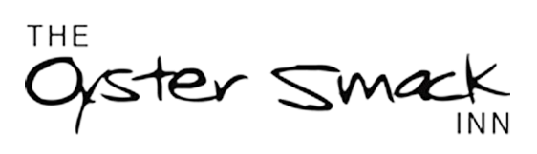
B R I N G Y O U R O W N W I N E
(Wine only)
£30.00 Each
A la carte menu
unavailable during BYO
S T A R T E R S

YELLOW SPLIT LENTIL, COCONUT AND TURMERIC SOUP
Crusty sourdough bread (gfa)

KING PRAWN TOSTADA
Cherry tomatoes, radish salad and smashed avocado

BBQ PULLED PORK BAO BUN
With pickled vegetables

CHARGRILLED TILLINGHAM ASPARGUS
Romesco sauce and shaved parmesan (gf) (v) (vga)

CHICKEN LIVER PATE
Toast and house chutney (gfa)

M A I N S

PANFRIED SEA BREAM FILLETS
Shiitake mushrooms, cannellini beans, curly kale, and sesame dressing (gf)

BUTTER CHICKEN CURRY
Basmati rice, mango chutney and popadom

BEEF FILLET WELLINGTON (+£8)
Parmesan truffle mashed potato, honey roast carrots and port jus

PULLED AUBERGINE, HARISSA RAGU
Tagliatelle, toasted almonds, and shaved vegetarian parmesan (v) (vga) (gf)

SLOW ROAST BELLY OF PORK
Apple compote and crispy crackling, mashed potato, gravy, and mixed vegetables (gfa)
D E S S E R T S

BLACK FORREST MILLE FUILLE
Layers of puff pastry, chocolate cream and mixed berries (v)

APPLE AND RHUBARB CRUMBLE TART
With custard (add ice cream £1) (v)

STRAWBERRY KULFI (INDIAN ICE CREAM)
Roasted strawberries, cardamon caramel and walnuts

HOMEMADE HONEYCOMB
Vanilla ice cream, warm chocolate sauce (v), (gf), (vga)
CHEESE AND BISCUITS (£4 SUP)
Served with apple, grapes, celery, crackers, and house chutney (v), (gf available)
Black Bomber, French Brie, Cashel Blue, and Goats Cheese

